Autocoding test of a two order model

We have seen in the Code Generation Tutorial that the Autocoding works quiet well. But we may not truly understand all the code generated.
Knowing that for the project we will autocode a lot of blocks and program a main in order to simulate the complete model behaviour, we have to learn how to combine all the generated codes.
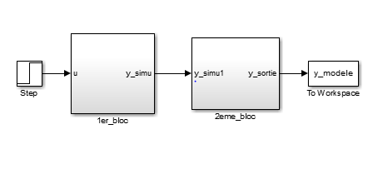
That is why, we decide to simulate a two order model presented below by re-using the codes generated for the first order model.
Figure 1: Two order model
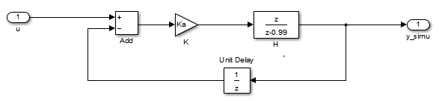
The two blocks are the same except the gain Ka (block 1) and Kb (block 2).
Figure 2: First order model _ Block 1

In the Tutorial, we autocoded the block 1. And as presented on the Simulink model, the two order model will take as an input “u” which is actually the block 1 input and as an output “y_sortie” which corresponds to the block 2 output.
How do we succeed to combine the blocks?
- Creation of the project
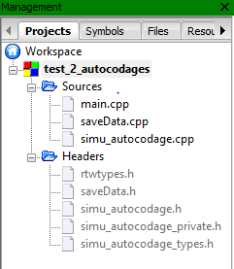
Firstly, we create a C++ project on Code Blocks as shown in the Tutorial. Then we add the files of the autocoded block as you can see in the following figure:
Figure 3: Project creation

- The Main
Autocode a model is to create a class which contains all the functions and all the variables of this model.
So in our case, when we autocoded the First order model, we actually create a class of first order models in which you can change the gain. The name “simu_autocodage” is because we named the Simulink file like this.
The “simu_autocodage.h” file is a header which contains the declaration of all the functions and all the variables as you can see on the figure below:
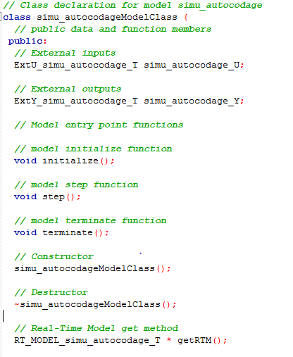
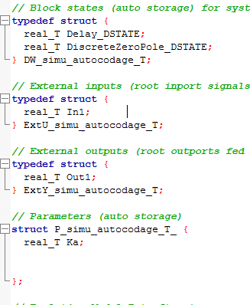
Figure 4: Simu_autocodage header

According to this figure, it appears that the input and the output are in a structure. Which means that if you have to autocode a block with many inputs (or outputs), you have to use buses in order to have only one structure with all the inputs (or outputs).

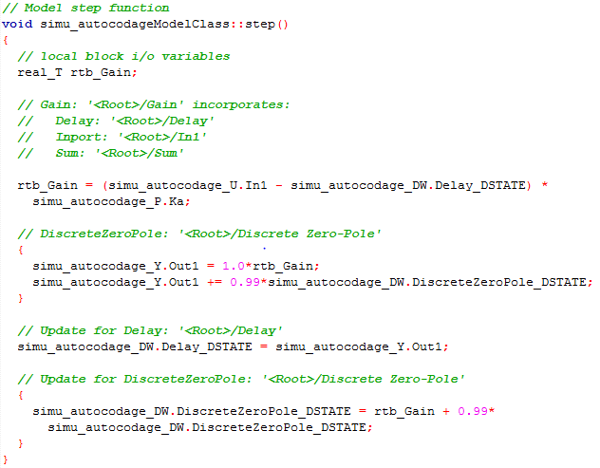
The “simu_autocodage.cpp” contains the Initialization function, the Class basic functions (constructor, destructor) and the function realized in the block which presented in the following figure:
Figure 5: The block function

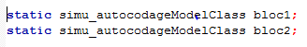
With all this, a block is just an object of the Class that we autocoded. In our case, to realize the two order model we started by creating two objects of the simu_autocodage Model Class:
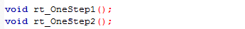
We also duplicated for each block, the function which allows to advance in the block:
As we said previously, the input “u” is the block 1 input and the output “y_sortie” is the block 2 output. So we did this code in the main:
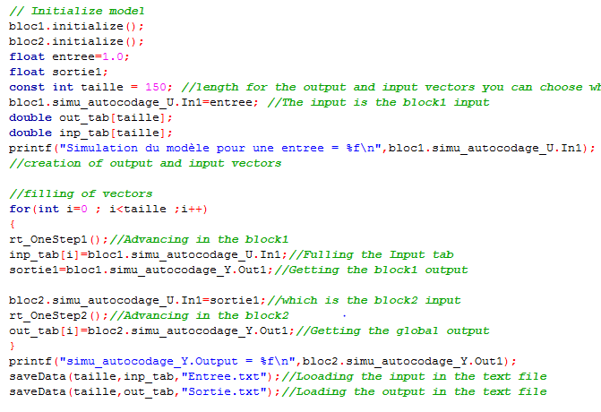
Now that we know how to use properly the code generated by the autocoding we can now proceed for the block listed in the Architecture Document.
Figure 6: Main of the second order model
The main representing the behaviour of our system will be coding according to the sequence diagram.

